Department of Computer Engineering

Practical - 9

Practical Title: Secure User Registration with Database Insert, Duplicate Email Check, and Password Hashing

Problem Definition: Implement secure user registration by inserting user details into MySQL using MySQLi. Validate input on frontend and backend, check duplicate email/username, hash passwords using password_hash(), and display appropriate messages.

Theory :
- Is password_hash() used before storing passwords?
Yes. PHP's password_hash($password, PASSWORD_BCRYPT, ['cost' => 12]) is used before executing the MySQL INSERT. Bcrypt applies an adaptive cost factor along with a 128-bit pseudo-random salt, making hashes resilient against brute-force, rainbow table, and dictionary attacks.

Is duplicate email/username checked?
Yes. Prior to database insertion, a prepared query runs: SELECT id, username, email FROM users WHERE username = ? OR email = ? LIMIT 1. If a match is found, the registration halts and specific contextual error messages are returned.

Are frontend and backend validations consistent?
Yes. Both JavaScript/HTML5 client-side and PHP server-side enforce the same rules: name length, email format (filter_var), username alphanumeric regex, password complexity. Server-side re-validation prevents bypass via direct API calls.

What security extensions are incorporated?
Prepared statements block SQL injection. CSRF tokens validated via hash_equals() prevent cross-site request forgery. Each account creation writes a record to the audit_logs table.

Implementation / Output / Result
$hashed = password_hash($password, PASSWORD_BCRYPT, ['cost' => 12]);
$stmt = $conn->prepare("INSERT INTO users (username, email, password, full_name, role) VALUES (?, ?, ?, ?, ?)");
$stmt->bind_param("sssss", $username, $email, $hashed, $full_name, $role);
$stmt->execute();

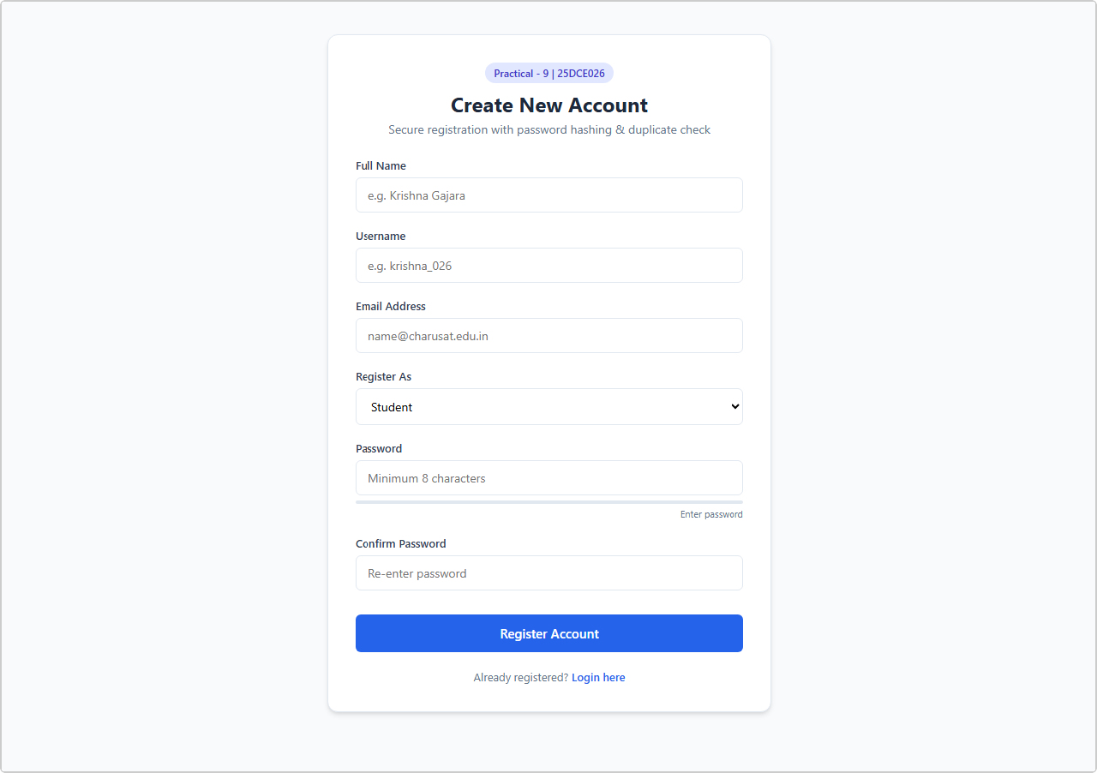
Output 1: User Registration Form with Real-time Validation and Password Strength Meter
Live browser screenshot: Registration form with Full Name, Username, Email, Role dropdown, Password strength bar.

Output 2: Duplicate Email & Username Prevention — Error Banners
Live browser screenshot: Submitting 'admin' / 'admin@charusat.edu.in' triggers red error banners: "Username is already taken" & "An account with this email already exists".

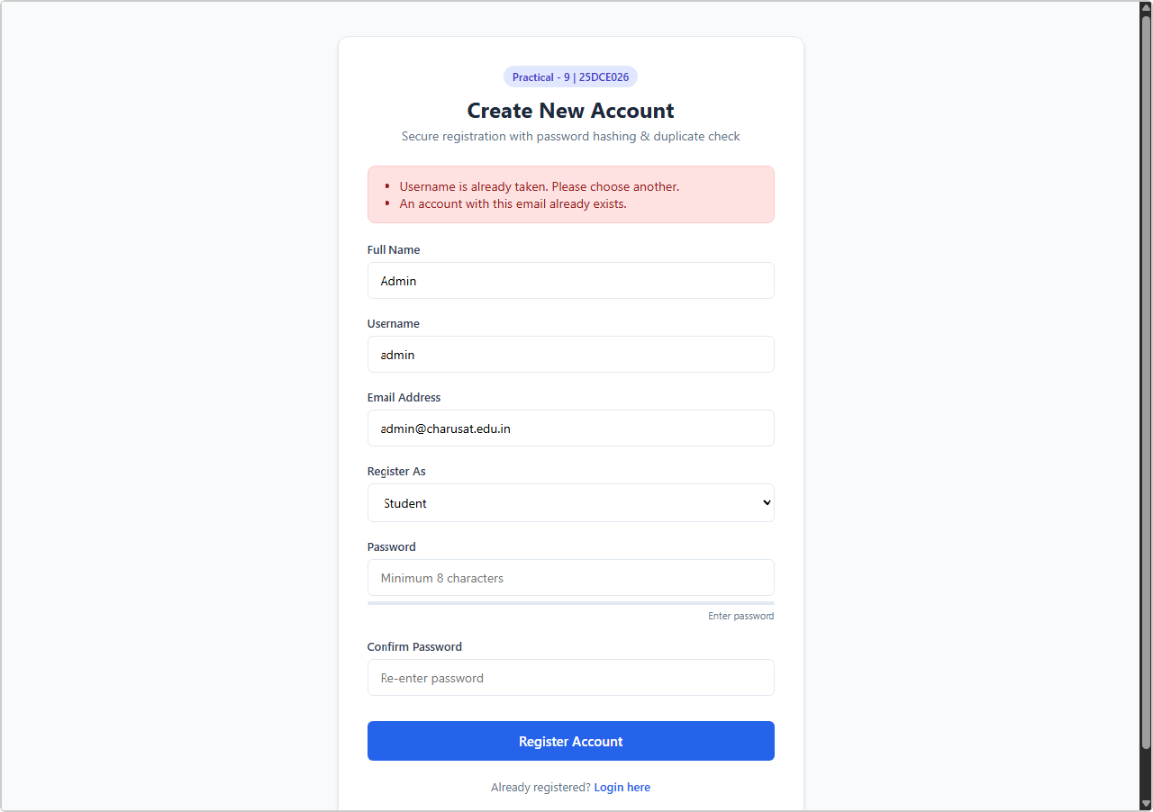

GitHub Repository Link:
https://github.com/bhavya13032007/studenthub/tree/main

Learning Outcomes:
- Implemented secure user registration adhering to OWASP web application security standards.
- Applied cryptographic one-way hashing using PHP's password_hash() with PASSWORD_BCRYPT.
- Eliminated SQL Injection threats through MySQLi parameterized prepared statements.
- Enforced consistent dual-layer input validation across both client and server domains.
- Engineered duplicate-checking routines for unique credentials prior to database persistence.
- Integrated CSRF anti-forgery tokens and automated audit trail logging.
- Tested and validated edge cases involving invalid formats, weak passwords, and duplicate registrations.

